Factual Update for Sports – COVID-19 (Coronavirus) Update
As most are aware, there are increasing numbers of COVID-19 coronavirus cases. Whilst the majority of cases are in China, there has been an increase of cases in other countries.
Current advice from the UK Department of Health is evolving and specific advice varies according to the area. If you have visited any of the countries noted, follow the specific advice and dial NHS Direct or NHS 24 on 111 for further guidance. The list is likely to change as new cases are found.
- Iran
- specific lockdown areas in northern Italy
- ‘special care zones’ in South Korea
- Hubei province (returned in the past 14 days)
- Vietnam, Cambodia, Laos, Myanmar
- Mainland China, Thailand, Japan, Republic of Korea, Hong Kong, Taiwan, Singapore, Malaysia, Macau
Facts and Prevention
It is important to remember that COVID-19 is mainly transmitted by large respiratory droplets, either aerosolised secretions or through direct or indirect contact with contaminated surfaces. It has also been detected and potentially transferable from blood, faeces and urine. It can remain on surfaces for several days. The current view is that COVID-19 has a 5-7 day incubation period but it may be as long as 14 days.
Things you can do now to minimise risk:
- Excellent hand washing regularly through the day + use of hand-based gel / foam. Normal soap is incredibly effective in destroying the cell membrane of the virus and killing it immediately. In fact, it reduces risk by 54% if you do it regularly and do it well. Dry hands thoroughly afterwards with either disposable paper towels or a hand drier.
- Regular cleaning of common surfaces (door handles, equipment) with normal soap-based detergents, and avoid touching too many public surfaces if you can.
- Ensure you’re healthy and well. Eat well / sleep well – keep your immune system in top shape.
- Risk avoidance – be mindful of public spaces e.g. supermarkets, restaurants, shopping malls etc. and avoid people who are coughing / sneezing. Face masks are probably ineffective.
- Isolation of cases – anyone with respiratory symptoms (dry cough, fatigue, sore throat) and a temperature should self-isolate and contact NHS Direct on 111.

If you are unwell in the UK:
- DO NOT go to your health centre, Institute facility or hospital but call NHS direct or NHS 24 on 111 for further advice.
- There are clear published guidelines for health professionals on how to manage cases
If you are unwell whilst abroad:
- Be aware that the status of where you are travelling to may change while you are there. This could impact on your travel back to the UK.
- Be aware of how to access medical care abroad.
- You may be asked to remain where you are and the local healthcare team will come to you to assess your symptoms.
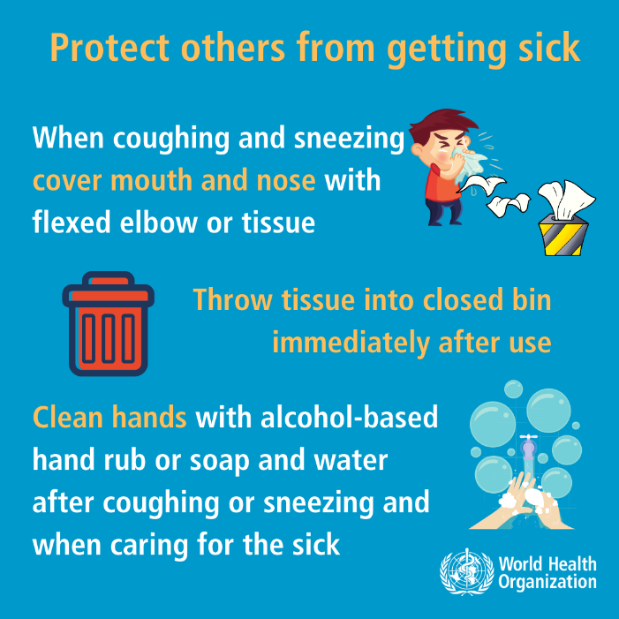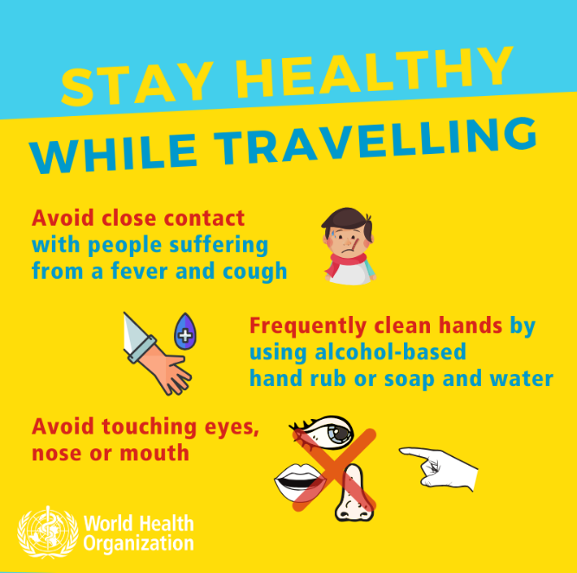
World Health Organisation YouTube video: https://youtu.be/mOV1aBVYKGA
Useful links to regularly updated advice
Public Health Agency
https://www.publichealth.hscni.net/news/covid-19-coronavirus

Dept of Health ( UK Government ) will be updated a 2pm daily via https://www.gov.uk/guidance/wuhan-novel-coronavirus-information-for-the-public

World Health Organisation situation report ( updates )
https://www.who.int/emergencies/diseases/novel-coronavirus-2019/situation-reports/

Foreign and Commonwealth Office
https://www.gov.uk/guidance/travel-advice-novel-coronavirus

Advice for Healthcare Professionals
(Primary Care) https://www.gov.uk/government/publications/wn-cov-guidance-for-primary-care

